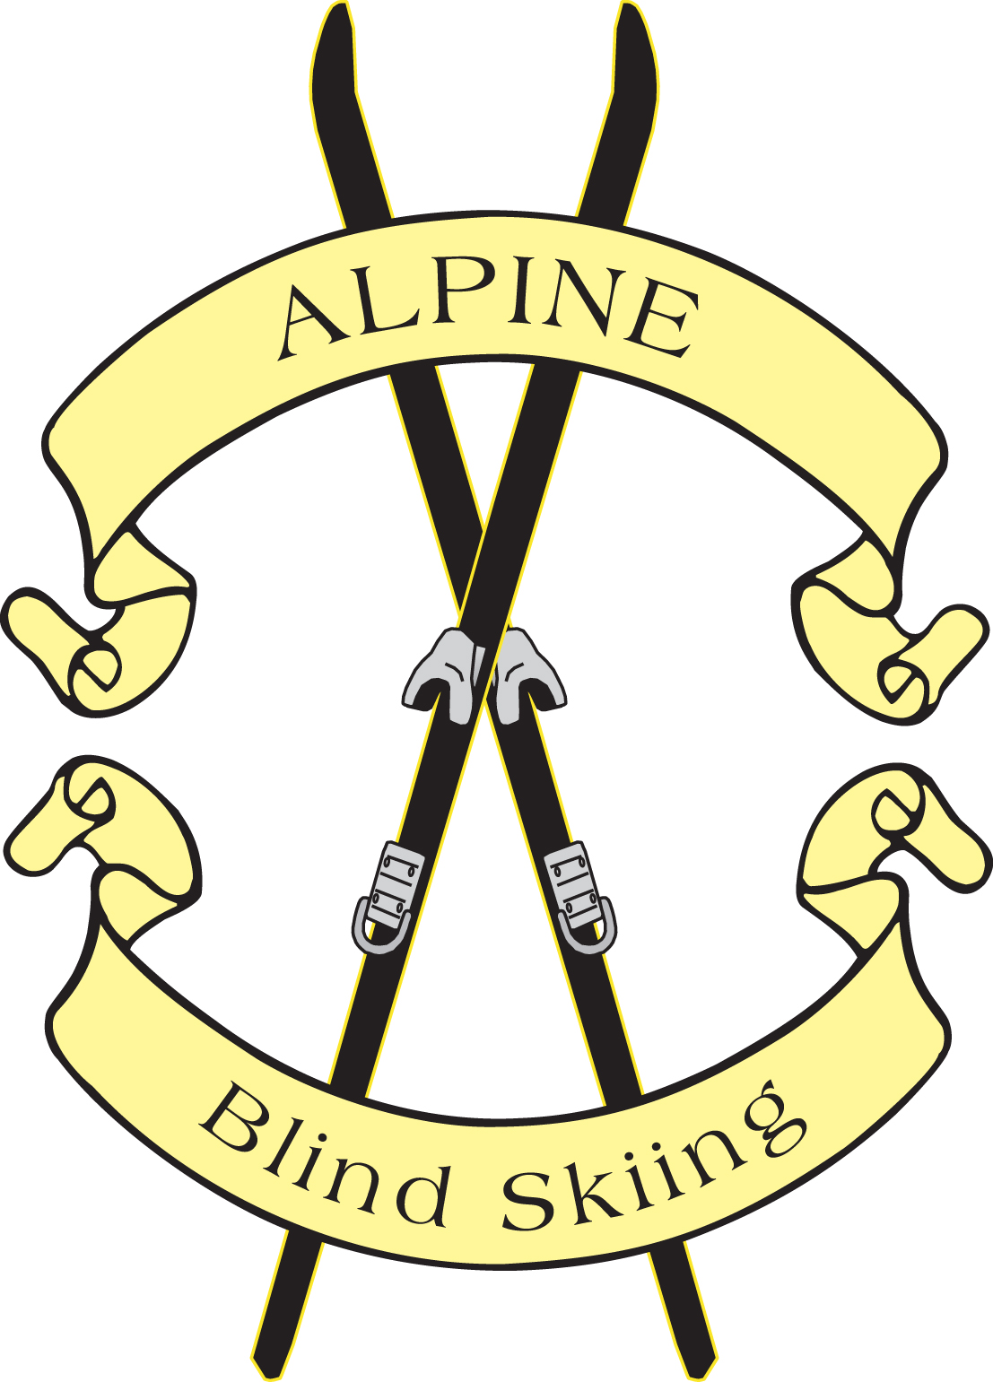 Alpine Blind Ski Club
Application

Name:________________________________Date of Birth____________________
Street Address:________________________________________________________
City, State & Zip Code:__________________________________________________
Phone:__________________________Work________________________________
E-Mail_______________________________________________________________

Will you be a: Guide___ Skier___ Volunteer___ Booster___

If you are guide, Skiing experience/type: Exec___ Good___ Average___Beginner___
How long have you been skiing: 2yrs___ 5yrs___ 10yrs___ more___

If you are a Blind skier, degree of Vision:___________________________________
Are there any pertinent medical needs to be aware of, if yes, please describe:
Description:__________________________________________________________
____________________________________________________________________

Health Ins. Provider:__________________________________________________
Emergency contact person:_____________________Phone:___________________

MEMBERSHIP DONATION
A fifteen dollar membership donation must accompany this application. If unable to pay do to financial hardship, please explain on reverse side, this is a two year Application.
RELEASE
Whereas Alpine Blind Ski Club, has initiated a blind skiing program, consisting of instruction and other skiing activities, and whereas the participants acknowledge that the said activity is hazardous, and the participants are liable to become, and subject to injury. Therefore, in consideration of the participant being able to participate in the said program, shall follow all policies, rules and regulations set forth by Alpine Blind Ski Club, and for other good and valuable consideration and sufficiency which is hereby acknowledged, is agreed as follows: The participant, his/her parents or guardian for themselves and for their heirs, executors, administrators do hereby and herewith RELEASE AND HOLD HARMLESS Alpine Blind Ski Club , instructors, guides, ski area operator, ski slope operator, ski lift operator, or operator of any other means of getting to or from the ski area from any and all liability that may occur because of any injury or loss to the participant, his/her parent or guardian, or any one, arising from or being associated with Alpine Blind Ski Club, to include specifically by the representation and not by the way of limitation, transportation to and from the place of said activity and any incidental activities of the said program. Further, the participants, his /her parent or guardian state and acknowledge that there is hospitalization, accident and other insurance on or for the said participant provided by the parties executing this release and therefore the said participant and/or his/her parent or guardian acknowledge that they shall provide at their own expense any and all said necessary insurances. I/we understand that any participant under ten years of age MUST have a parent or legal guardian on side before said participant will be allowed to participate in any activities of the Alpine Blind Ski Club. I/we, the undersigned, have read the foregoing, acknowledge understanding it and know that by signing it, I/we wave my/our rights, and the right of each of us to claim or demand damages for any injury sustained as part of my/our participation in any activity of Alpine Blind Ski Club.

PARTICIPANT’S SIGNATURE: DATE:
If any participant is a minor,
PARENT OR LEGAL GUARDIAN’S SIGNATURE:

